Directions to McCarl’s

Go to East Bypass (Texas 6) go to 2818/Emerald Parkway intersection
Go East on Emerald Parkway (toward Merrill Lynch not toward Walmart)
Enter Emerald Forest Subdivision Take 3rd Left onto Appomattox
Go ½ block and turn on Fawn Court
McCarl’s is 2100 Fawn Court 693-5694

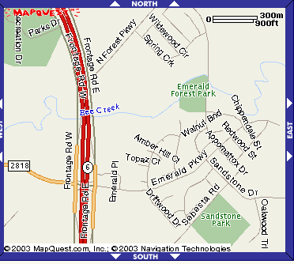
McCarl’s
