Hands On 6

Due date: 11:59 pm 11/2/2017

Instructions:

Save HandsOn4.gms as HandsOn6.gms

a) Fix the infeasible small model using gams check, tell me which parameter should be change and why.

b) Do a comparative analysis on a number of price scenarios (using the LARGE model without parameter changes): Using a loop statement to run 11 scenarios (“base” will be the original price) on the following price changes in levels.

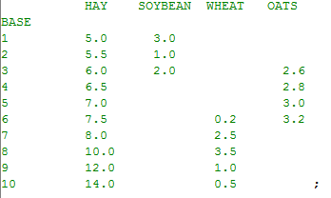

In the loop, enter a comparative report which includes ingredient price, ingredient usage, and total mix cost. Make sure the output report should be the following format.



*Hint: If your table is wrapped to two part, you can put “pw=200” in the command window right beside the run button to set the output page width in order to show the whole table.*

*If the value of price change of crop1 is zero, it means the price of crop1 is the same as its base price.*

*Requirement:*

*1. Email me* ***HandsOn6.gms*** *with the code associated with report writing in it.*

*2. Also email me the* ***HandsOn6.lst*** *file* ***with the report tables you create****. Note that the correct answers may be different from the table above. The table is just to show you the format that I want.*

*3. Write two or three sentences to explain what you changed to make the small model feasible and why that parameter leads to infeasible solution.*